Contractor Change Order Review
Quick Start Guide

- Accessing Your Task – Follow the Links in the Email Notification to access the Change Order for review.
Click on ‘Click here’ link to open the Change Order for review.
You can access your task from a PC, laptop, and most tablets or mobile phones.
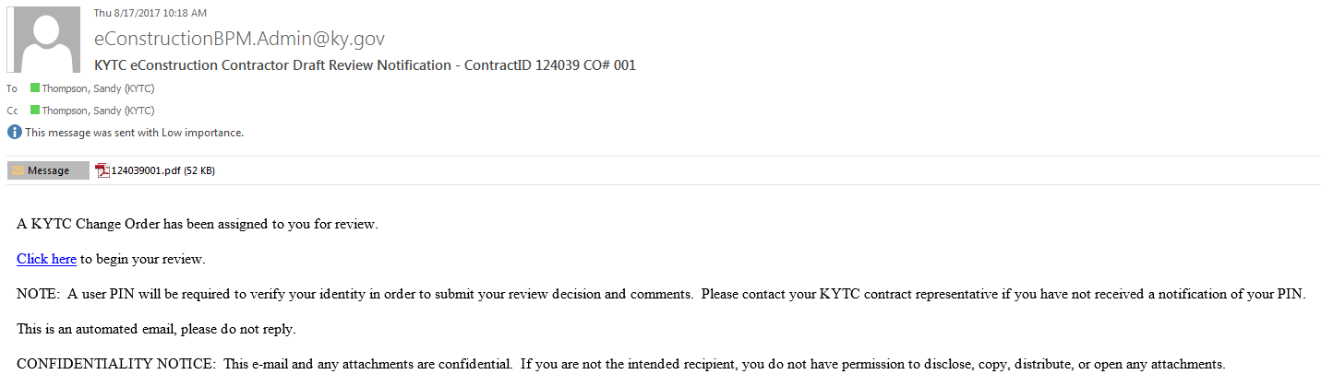
Note: The email contains a PDF of the Change Order for your files.
When using iPhone or iPad in ‘Private Browsing’ mode, you may receive a message indicating that your version of Safari is not supported. You can continue by clicking on ‘Continue Unsupported’ or by using normal browsing mode on your device.
Unsupported Safari Message

- Review the Change Order
Change Order Data is read only and is contained in two sections:
- Change Order Information
- Funding Strip
Navigate to different sections by selecting the section or selecting ‘Next’. Navigate on the page using the scroll bar.
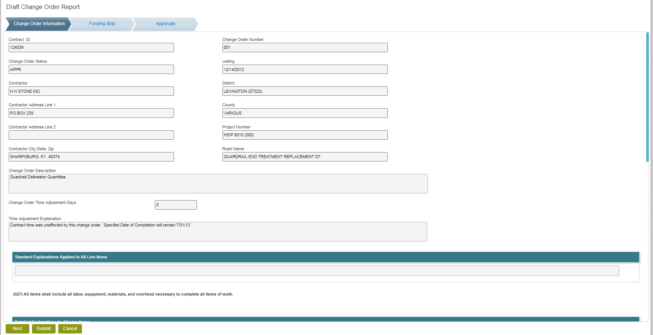

- Submit Your Decision
Navigate to the Approvals Section.
Enter your verification PIN. (Contact Matt Looney or Erika Drury if you have not received a PIN)
Select your Decision, then select Submit
- If you select Rework, you must enter comments in the General Comments area and select ‘Add Comment’. This selection sends the Change Order back to KYTC to address the issues defined in your comments. Once the Change Order is updated, it will be sent back to you for review and approval.
